­­Supplementary Material

**Modeling suggests SARS-CoV-2 rebound after nirmatrelvir-ritonavir treatment is driven by target cell preservation coupled with incomplete viral clearance**

Tin Phan, Ruy M. Ribeiro, Gregory E. Edelstein, Julie Boucau, Rockib Uddin, Caitlin Marino, May Y. Liew, Mamadou Barry, Manish C. Choudhary, Dessie Tien, Rebecca F. Gilbert, Zahra Reynolds, Yijia Li, Shruti Sagar, Tammy D. Vyas, Yumeko Kawano, Jeffrey A. Sparks, Sarah P. Hammond, Zachary Wallace, Jatin M. Vyas, Jonathan Z. Li†,Mark J. Siedner†, Amy K. Barczak†, Jacob E. Lemieux†, and Alan S. Perelson*.

†Equal contributions

*Corresponding author: Email: [asp@lanl.gov](mailto:asp@lanl.gov) (ASP)

**The PDF file includes:**

S1 to S10 Text

S1 to S9 Figs

S1 to S4 Tables

**S1 Text: Nirmatrelvir concentration and drug effectiveness dynamics**

The concentration of nirmatrelvir is modeled based on a standard two-compartment pharmacokinetic model with first-order absorption rate *ka* and first-order elimination rate *ke* [1].

,

where is the dosing interval (1/2 day), is the number of doses until time, and where is the bioavailability of the drug, is the mass of the drug administered in a dose (300 mg), and is the volume of distribution. Studies on the pharmacokinetics of nirmatrelvir taken with ritonavir (N-R) [2] show that the elimination rate is 2.8/day, and the maximum concentration after a single dose is 4.42×103 nM, which is achieved at 3 hours [2]. The maximum concentration from a single dose is given by the expression

which occurs at . Solving for from the expression for gives 17.5/day. Then, solving for in the expression for gives:

The drug effectiveness is given by the Emax model, where EC50 62 nM [2] and we assume the maximum drug effectiveness for all our simulations and model fits to data. Graphs of and for the parameters given above are provided in S1 Fig, which shows a simulation for a 5-day course of N-R starting on day 5 and ending on day 10. Note that the drug concentration reaches a stable oscillatory level, more than 50 times above the EC50, around day 2 post treatment initiation (S1a Fig), which is consistent with the observation that drug concentration stabilizes after two daysand leads to a quasi-constant high efficacy of ~0.98 (S1b Fig).

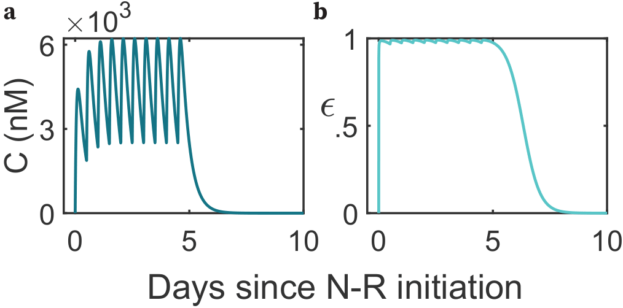

**S1 Fig.** Simulation of drug concentration C (nM) and effectiveness over the 5 day/10-dose schedule starting on day 0 (with the 10th dose taken on day 4.5) with the given kinetic parameters. **a**. Nirmatrelvir concentration (nM). **b**. The drug effectiveness over time is based on the concentration of nirmatrelvir and an Emax model.

**S2 Text: Estimates of population and individual parameters**

The estimated population and individual parameters for the model (main text) are given in S1 and S2 Tables, respectively.

|  |  |  |  |
| --- | --- | --- | --- |
|  | Fixed effects  (S.E./R.S.E.) | Random effects  (S.E. / R.S.E.) | Individual  [min, max] |
| (mL / RNA copies per day) | 8.06 (0.11/1.42%) | 0.52 (0.15/29.5%) | [7.91, 8.26] |
| (RNA copes per mL per day) | 2.65 (0.063/2.37%) | 0.035 (0.013/37.7%) | [2.56, 2.70] |
| (per day) | 0.17 (0.054/30.9%) | 0.99 (0.28/28.7%) | [0.075, 0.5] |
| (per cell per day) | 6.49 (0.073/1.13%) | 0.077 (0.025/32.3%) | [6.45, 6.52] |
| (per day) | 1.85 (0.13/6.79%) | 0.28 (0.049/17.5%) | [1.01, 3.10] |
| (days) | 13.1 (0.61/4.62%) | 0.61 (0.097/16.0%) | [10.47, 20.97] |
| Time to symptom onset (days) | 2.06 (0.92/44.6%) | 0.39 (0.59/151%) | [1.33, 3.39] |
| (cells) | 0.67 (0.24/36.4%) | 0.95 (0.34/35.9%) | [0.37, 2.74] |

**S1 Table.** Best fit population parameters.

|  |  |  |  |  |  |  |  |  |  |
| --- | --- | --- | --- | --- | --- | --- | --- | --- | --- |
| **ID** |  |  |  |  |  |  |  |  | **Classification** |
| 1 | 8.1 | 2.67 | 0.29 | 6.48 | 1.96 | 14.6 | 1.89 | 1.13 | Rebound |
| 2 | 7.93 | 2.69 | 0.28 | 6.47 | 2.39 | 11.43 | 3.09 | 0.69 | Rebound |
| 3 | 8.07 | 2.67 | 0.28 | 6.48 | 1.65 | 12.91 | 1.74 | 2.74 | Rebound |
| 4 | 8.02 | 2.69 | 0.36 | 6.48 | 2.13 | 13.71 | 1.75 | 1.22 | Rebound |
| 5 | 8.05 | 2.65 | 0.19 | 6.49 | 2.66 | 13.9 | 1.96 | 0.78 | Rebound |
| 6 | 8.01 | 2.66 | 0.16 | 6.49 | 1.7 | 12.3 | 2.34 | 0.57 | Rebound |
| 7 | 8.07 | 2.67 | 0.25 | 6.48 | 2.02 | 16.58 | 1.9 | 1.08 | Rebound |
| 8 | 8.2 | 2.56 | 0.19 | 6.49 | 2.81 | 11.26 | 1.33 | 0.68 | Rebound |
| 9 | 8.01 | 2.68 | 0.3 | 6.48 | 2.04 | 14.52 | 2.05 | 1.07 | Rebound |
| 10 | 8.15 | 2.64 | 0.16 | 6.48 | 2.09 | 11.71 | 2.25 | 0.84 | Rebound |
| 11 | 8.08 | 2.61 | 0.15 | 6.47 | 2.06 | 16.24 | 1.5 | 0.73 | Rebound |
| 12 | 8.08 | 2.64 | 0.21 | 6.47 | 3.09 | 11.93 | 2.05 | 0.85 | Rebound |
| 13 | 8.08 | 2.63 | 0.075 | 6.5 | 2.22 | 20.97 | 1.91 | 0.39 | Rebound |
| 14 | 8.11 | 2.67 | 0.29 | 6.48 | 1.81 | 14.55 | 1.81 | 1.72 | Rebound |
| 15 | 8.06 | 2.66 | 0.2 | 6.46 | 2.04 | 12.7 | 1.82 | 1.5 | Rebound |
| 16 | 8 | 2.66 | 0.22 | 6.48 | 2.32 | 13.38 | 2.33 | 0.74 | Rebound |
| 17 | 8.12 | 2.62 | 0.16 | 6.48 | 2.12 | 10.65 | 1.81 | 0.59 | Rebound |
| 18 | 8.12 | 2.67 | 0.25 | 6.49 | 1.57 | 14.77 | 1.93 | 2.59 | Rebound |
| 19 | 7.94 | 2.68 | 0.21 | 6.48 | 3.1 | 12.9 | 3.39 | 0.71 | Rebound |
| 20 | 7.95 | 2.69 | 0.16 | 6.49 | 1.93 | 15.87 | 2.57 | 0.54 | Rebound |
| 21 | 8.15 | 2.64 | 0.5 | 6.49 | 1.51 | 12.5 | 1.63 | 1.17 | No Rebound |
| 22 | 8.1 | 2.63 | 0.13 | 6.5 | 1.93 | 11.04 | 1.66 | 0.44 | No Rebound |
| 23 | 8.04 | 2.65 | 0.11 | 6.49 | 1.85 | 10.47 | 2.43 | 0.48 | No Rebound |
| 24 | 8.15 | 2.63 | 0.12 | 6.49 | 2.2 | 13.18 | 1.95 | 0.46 | No Rebound |
| 25 | 8.06 | 2.64 | 0.13 | 6.49 | 2.99 | 13.25 | 2.1 | 0.6 | No Rebound |
| 26 | 8.21 | 2.63 | 0.14 | 6.5 | 1.37 | 11.62 | 1.64 | 0.53 | No Rebound |
| 27 | 8.1 | 2.65 | 0.21 | 6.51 | 1.74 | 15.44 | 1.54 | 0.7 | No Rebound |
| 28 | 8.11 | 2.64 | 0.14 | 6.49 | 1.38 | 11.93 | 1.93 | 0.55 | No Rebound |
| 29 | 7.98 | 2.68 | 0.3 | 6.47 | 2.28 | 10.55 | 2.37 | 1.17 | No Rebound |
| 30 | 8.19 | 2.61 | 0.14 | 6.52 | 1.24 | 17.22 | 1.7 | 1.28 | No Rebound |
| 31 | 8.16 | 2.64 | 0.14 | 6.5 | 1.66 | 11.68 | 1.81 | 0.52 | No Rebound |
| 32 | 8.04 | 2.64 | 0.1 | 6.49 | 2.04 | 11.37 | 2.32 | 0.49 | No Rebound |
| 33 | 8.01 | 2.67 | 0.2 | 6.49 | 2.1 | 16.95 | 2.1 | 0.95 | No Rebound |
| 34 | 8.13 | 2.64 | 0.17 | 6.49 | 1.83 | 15.04 | 1.75 | 0.58 | No Rebound |
| 35 | 7.93 | 2.7 | 0.23 | 6.46 | 1.99 | 11.21 | 2.56 | 0.69 | No Rebound |
| 36 | 8.14 | 2.63 | 0.16 | 6.5 | 1.93 | 12.63 | 1.72 | 0.58 | No Rebound |
| 37 | 8.03 | 2.64 | 0.094 | 6.49 | 2.23 | 10.88 | 2.59 | 0.48 | No Rebound |
| 38 | 7.96 | 2.67 | 0.3 | 6.48 | 1.79 | 11.76 | 2.11 | 1.09 | No Rebound |
| 39 | 8.08 | 2.63 | 0.09 | 6.49 | 1.91 | 15.89 | 1.98 | 0.37 | No Rebound |
| 40 | 8.21 | 2.64 | 0.14 | 6.51 | 1.01 | 13.09 | 1.64 | 0.69 | No Rebound |
| 41 | 7.98 | 2.66 | 0.17 | 6.49 | 2.02 | 11.82 | 3.19 | 0.74 | No Rebound |
| 42 | 8.03 | 2.66 | 0.14 | 6.5 | 1.87 | 13.82 | 2.04 | 0.44 | No Rebound |
| 43 | 8.18 | 2.65 | 0.15 | 6.49 | 1.09 | 14.81 | 2.41 | 0.82 | No Rebound |
| 44 | 8 | 2.68 | 0.2 | 6.5 | 1.29 | 13.55 | 2.47 | 0.79 | No Rebound |
| 45 | 8.06 | 2.64 | 0.13 | 6.49 | 1.9 | 11.47 | 2.06 | 0.54 | No Rebound |
| 46 | 7.91 | 2.68 | 0.2 | 6.45 | 1.91 | 11.57 | 2.43 | 0.38 | No Rebound |
| 47 | 8.12 | 2.63 | 0.15 | 6.5 | 2.26 | 13.66 | 1.72 | 0.57 | No Rebound |
| 48 | 8.26 | 2.63 | 0.14 | 6.5 | 1.06 | 13.13 | 1.6 | 0.52 | No Rebound |
| 49 | 8 | 2.66 | 0.18 | 6.48 | 1.74 | 13.02 | 2.71 | 0.75 | No Rebound |
| 50 | 8.09 | 2.64 | 0.17 | 6.49 | 2.02 | 11.86 | 2.07 | 0.55 | No Rebound |
| 51 | 8.01 | 2.66 | 0.22 | 6.48 | 1.46 | 13.82 | 2.19 | 0.86 | No Rebound |

**S2 Table.** Best fit parameters for all treated participants. Note: is time of infection relative to the time of symptom onset (reported by the participants).

**S3 Text: Model Comparison**

We compared our model with previous models [3] and tested different covariates on model parameters (S3 Table). A covariate on the baseline death rate of infected cells () and on the half-saturation constant resulted in BICc improvements of 3.73 and 1.77, respectively. Monolix also suggested as a covariate between rebound and non-rebound individuals based on a Wald test. However, due to the small improvement in BICc score and the lack of a biological basis for the difference in value between the two groups, we chose to use a model without any covariates for the analysis in the main text.

Additionally, inspired by recent studies by Carlin et al. [4] and Esmaeili et al. [5], where the authors found that the *in vivo* efficacy of N-R is likely much lower than estimates based on *in vitro* assays, we estimated the value of each individual’s EC50 in our model. While adding EC50 as a fitting parameter and allowing individual variability in this parameter provides a slightly better fit than the model in the main text (-2LL = 1213.15 vs 1214.51), the added parameters resulted in a worse BICc score of 1308.01 vs 1299.50 (S3 Table).

|  |  |  |
| --- | --- | --- |
|  | -2LL | BICc |
| Target cell limited model | 1337.47 | 1392.82 |
| Innate immune response model | 1270.92 | 1346.03 |
| **Main text model – no covariates** | 1214.51 | 1299.50 |
| Covariate on transmission rate | 1220.18 | 1309.10 |
| Covariate on viral production rate | 1212.66 | 1301.58 |
| Covariate on transition into refractory rate | 1213.74 | 1302.66 |
| Covariate on maximal transition rate out of refractory | 1219.54 | 1308.46 |
| Covariate on infected cell death rate | 1206.85 | **1295.77** |
| Covariate on timing of adaptive immunity | 1210.70 | 1299.62 |
| Covariate on half-saturation constant | 1208.81 | **1297.73** |
| Covariate on time to symptom onset | 1215.90 | 1304.82 |
| No covariate – estimating EC50 | | 1213.15 | 1308.01 |

**S3 Table.** Model fit comparison (Monolix 2023R1, Lixoft, SA, Antony, France). Bolded values are lower BICcscores than the main-text model without any covariate. When estimating, we obtain 2.22 (with standard deviation 1.07), which corresponds to an EC50 value of about 166 nM with (min, max) = (8.51, 29512). 39 individuals (15 rebound/24 non-rebound) have an estimated EC50 higher than the FDA reported value of EC50 = 62 nM [2].

**S4 Text: a model with target cell proliferation**

Target cell proliferation is an alternative mechanism that could allow the replenishment of target cells. Hence, we examine a model with an added target cell proliferation term and refer to it as “the logistic proliferation variation model.”

Here, is the maximum growth rate and is the homeostatic target cell population.

The logistic proliferation variation model captures the viral load data well (S2a Fig) and has a ‑2LL of 1214.39, which is an improvement of 0.12 over the main text model. However, its BICc is worse by about 10 points because of the addition of one new parameter.

The stratification of estimated parameters for the logistic proliferation variation model (S2b Fig) shows more similar distributions of model parameters between rebound and non-rebound compared to that of the main text model (Fig 2b). While both the main text and logistic variation models support the notion that earlier treatments correlate with rebound, the logistic proliferation variation de-emphasizes the differences in the innate immune response. Specifically, while there are apparent differences in the innate immune response parameters (*ϕ* and *ρ*) between rebound and non-rebound (S2b Fig), they are not as clear compared to the differences in the main text model (Fig 2b). Furthermore, differences in estimated viral dynamic parameters are also negligible. For instance, while the difference in viral infection rate is statistically significant (S2b Fig), the medians of the two distributions differ only by about 0.01 log. Altogether, the logistic proliferation variation strongly favors early treatment as the main determinant for rebound.

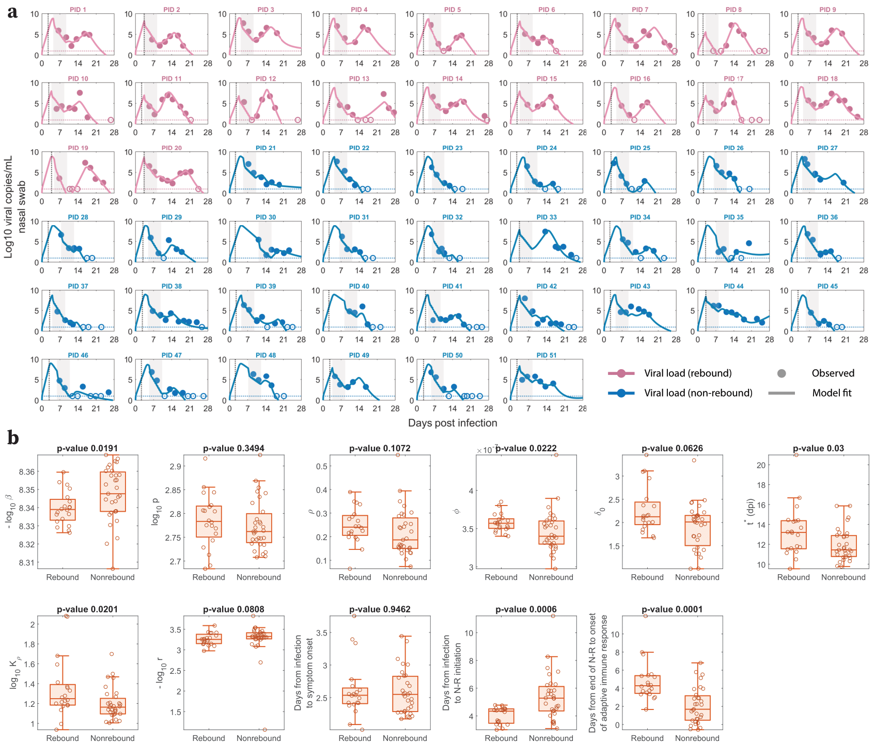

**S2 Fig.** Model fits for the logistic proliferation variation. **a.** Model fits to nasal viral loads of rebound (pink) and non-rebound (blue) individuals. The shaded area is the duration of N-R treatment. The dotted horizontal line is the limit of detection (LoD) for the RT-qPCR assay. Filled and open circles are data above and below the LoD, respectively. The dotted black vertical line indicates the estimated time from infection to symptom onset **b.** Box plots of best fit parameters and timing of N-R stratified by individuals who rebound vs. those who do not. The lower and upper limits of the box represent the first and third quartile, respectively. The line inside the box is the median and the whiskers connect the top/bottom of the box to the max/min values that are not outliers (data points further than 1.5 times the interquartile range). Overlaid circles are individual parameter values. P-values are calculated using the Mann-Whitney U test.

**S5 Text: Target cell preservation by the innate immune response**

To understand why including an innate immune response is important to define rebound vs. no rebound, we analyzed in more detail the model predicted dynamics of target cells and refractory cells. We compared the change in the number of target cells over time with the critical number needed for viral growth (see Methods). These analyses are presented in S3 Fig. Following infection, the innate immune response converts some target cells into cells refractory to infection [6–9], leading to an effective target cell limitation. In some participants, both rebounders and non-rebounders, this effect of target cell limitation (dotted-dashed black curves, S3 Fig) occurred just ahead of N-R initiation. We also noted that the critical number of target cells needed for viral growth was elevated during treatment due to a reduction of the viral production rate by N-R. Once treatment ended, this threshold returned to its pre-treatment level at the same time that refractory cells returned to being susceptible. If the level of target cells exceed this threshold (when the pink/blue curves cross above the dotted-dashed black curve, S3 Fig), it indicates that virus has sufficient resources to rebound. The model also predicts that all participants developed a robust innate immune response, which preserves the majority of the initial number of target cells (i.e., the mean [min, max] fraction of initial number of cells susceptible to infection that remain uninfected (target cells plus refractory cells) on day 28 post infection was 0.58 [0.46, 0.87]). This observation agrees with previous studies of influenza A showing that innate immune responses could produce the effect of target cell limitation while preserving a large fraction of the initial target cells [10,11].

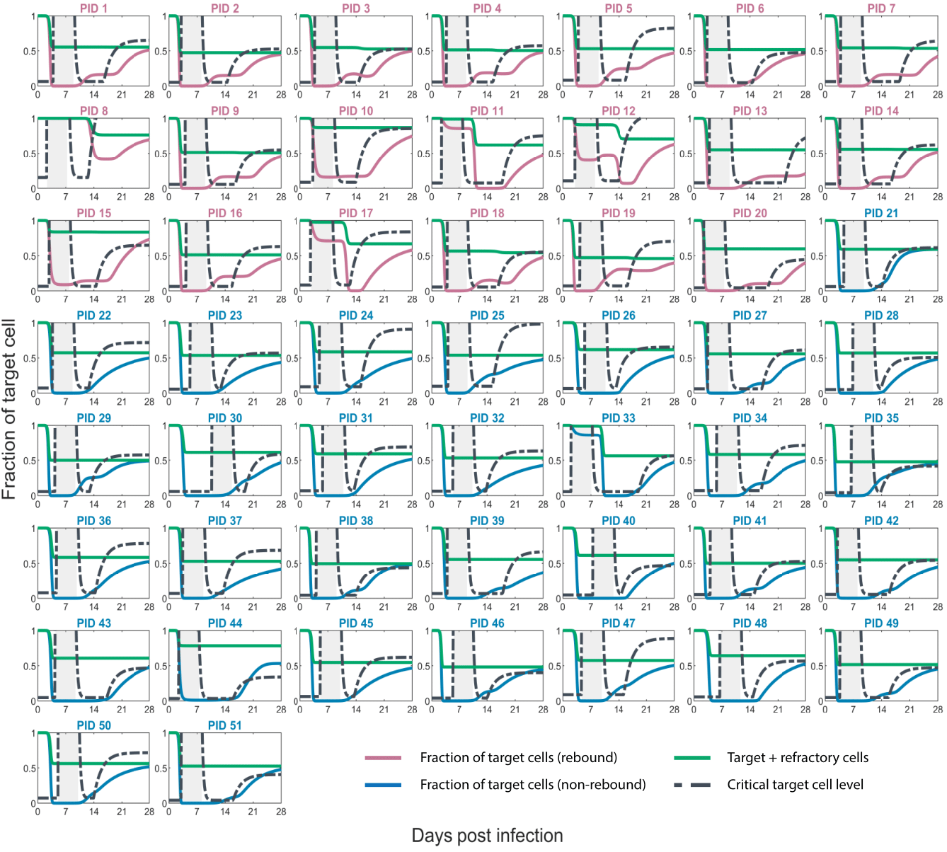

**S3 Fig.** Model predicted fraction of target cells (available for infection) relative to the maximum target cell count for rebound (pink) and non-rebound (blue) individuals. The shaded area is the duration of N-R treatment. When the fraction of target cells is above the critical target cell level (dashed line), viral growth occurs, and when it is below, virus decays.

In order to examine how different variables in the model interact and change over time, we plot the model dynamics for a representative rebound and non-rebound individual (S4 Fig). For both individuals, we see that the initiation of N-R rapidly drove a reduction in viral load (S4a, d Fig). However, in both cases, at the time of treatment, over half of the susceptible target cells were preserved by the treatment and an effective innate immune response (green curves, S4b, e Fig). Due to the protective effect of the innate immune response, the number of target cells susceptible to infection (pink or blue curves) stayed below the critical threshold required for viral growth (dot-dashed black curve) during the duration of treatment (S4b, e Fig). Consequently, infected cells are lost rapidly (S4c, f Fig), which leads to a reduction in levels of type-I and type-III interferons (assumed to be proportional to the number of infected cells). Once treatment ended, the level of interferons appears to be insufficient to maintain the antiviral state, which allows refractory cells to return to being susceptible. This is indicated by the rise of the pink and blue curves to above the critical threshold (S4b, e Fig). Once an adaptive immune response began to emerge at days 16.5 and 15.0 for the rebounder and non-rebounder respectively, it increased the death rate of infected cells, which raised the critical threshold causing an ultimate viral decline. The main distinction between these two cases is the time of treatment initiation and the time the adaptive immune response began.

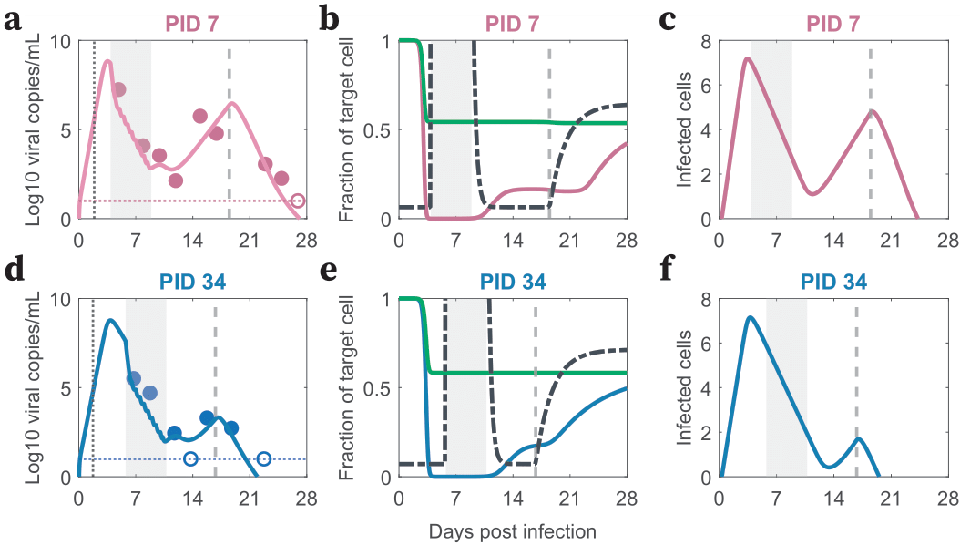

**S4 Fig.** Model dynamics: rebound (top row) and non-rebound (bottom row). **(a, d)**. Model fits to nasal viral loads of a rebound (pink) and non-rebound (blue) individual. The shaded area is the duration of N-R treatment. The dotted horizontal line is the limit of detection (LoD) for the RT-qPCR assay. Filled and open circles are data above and below the LoD, respectively. The dotted black vertical line indicates the estimated time from infection to symptom onset. The vertical dashed gray line indicates when the adaptive immune response began. **(b, e).** The simulated fraction of the initial number of target cells remaining is plotted in pink for the rebound and in blue for the non-rebound individual. The sum of target and refractory cells is plotted in green. The critical fraction of target cells required for viral growth is given by the black dashed curve. **(c, f).** The solid curve represents the number of productively infected cells.

We also examined the predicted dynamics of target cells for the logistic proliferation variation model (S5 Fig), which shows similar net regeneration effect of target cells compared to the innate immune response model (S3 Fig). This is likely due to (1) rebound occurring within days after the end of treatment, which limits the duration of target cell proliferation; and (2) the rate of logistic proliferation is scaled by the total number of cells (susceptible, infected, and refractory cells), so because of the strong preservation of target cells, the overall proliferation rate is limited.

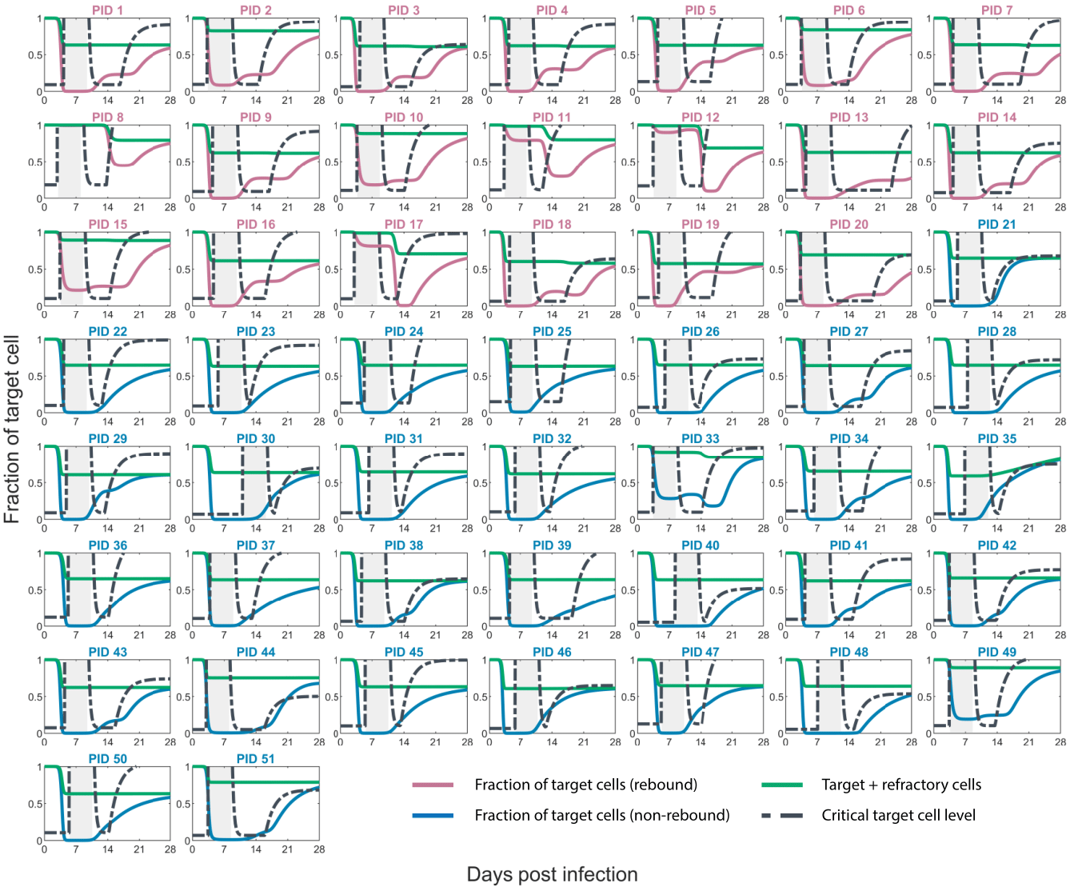

**S5 Fig.** Model predicted fraction of target cells (available for infection) relative to the maximum target cell count – logistic proliferation variation. The shaded area is the duration of N-R treatment. When the fraction of target cells is above the critical target cell level (dashed line), viral growth occurs, and when it is below, virus decays.

**S6 Text: Comparison of model parameters between treated and untreated individuals**

We apply the same modeling framework (as in the main text) to simultaneously fit the treated and untreated individuals from the same ongoing clinical cohort [12]. The data selection criteria are the same as in the main text (Data). In total, we analyzed data from 95 individuals (51 treated as in the main text and 44 untreated). The model recapitulates the viral dynamics of all individuals (S6a Fig). The parameter values, stratified by treated vs. untreated, show statistically similar distributions between the two groups (S6b Fig). The one exception is the onset of the adaptive immune response, where the estimated time of onset is delayed on average by 1.23 days for treated individuals compared to untreated individuals, with a 95% confidence interval (CI) of [0.44, 2.03] days (P=0.0026).

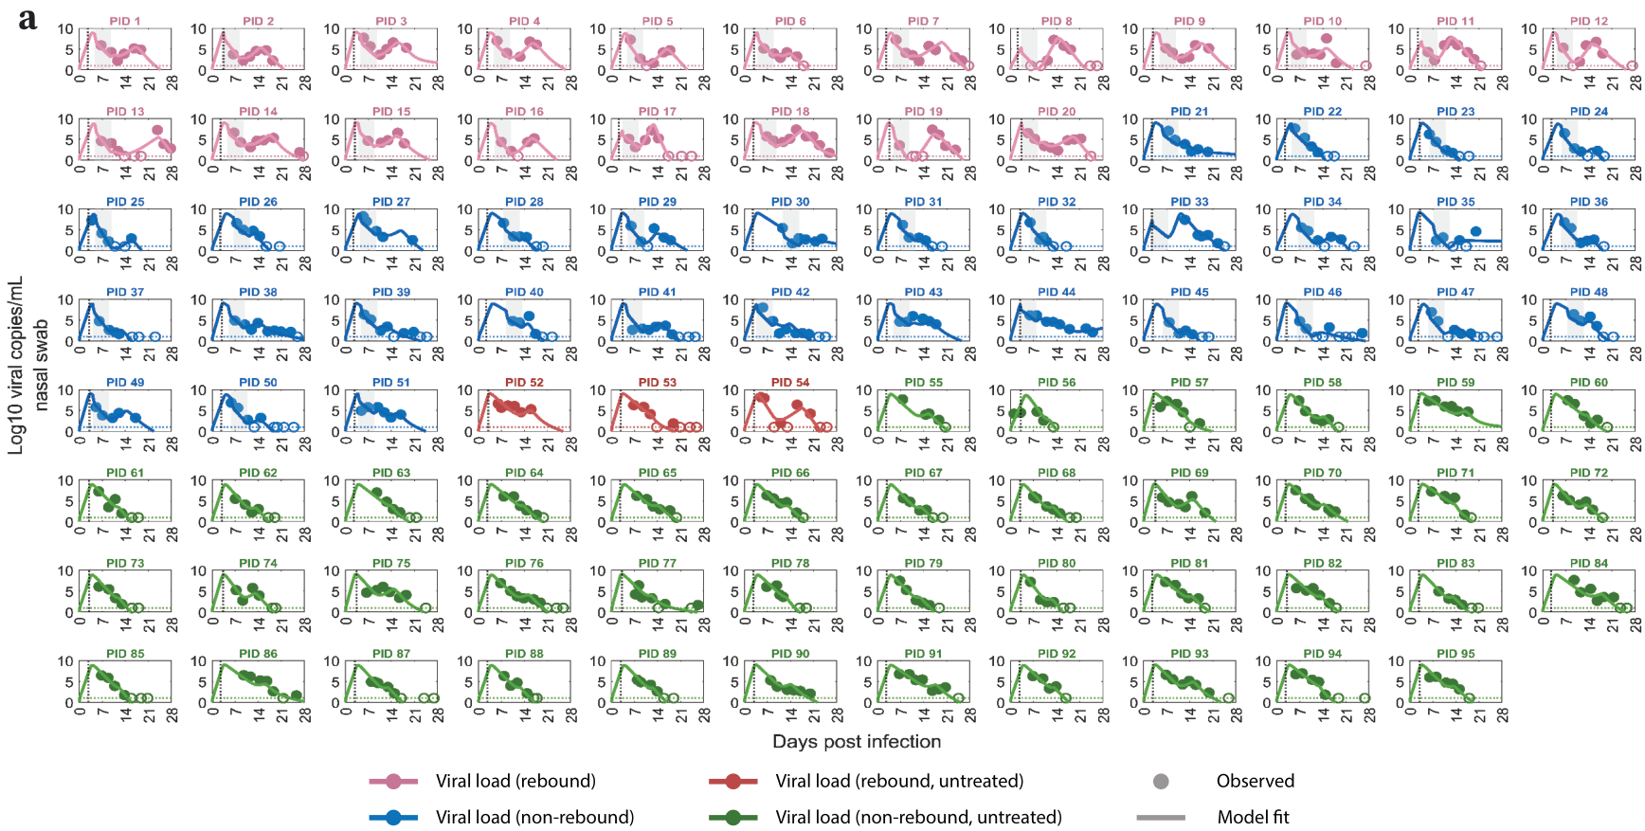

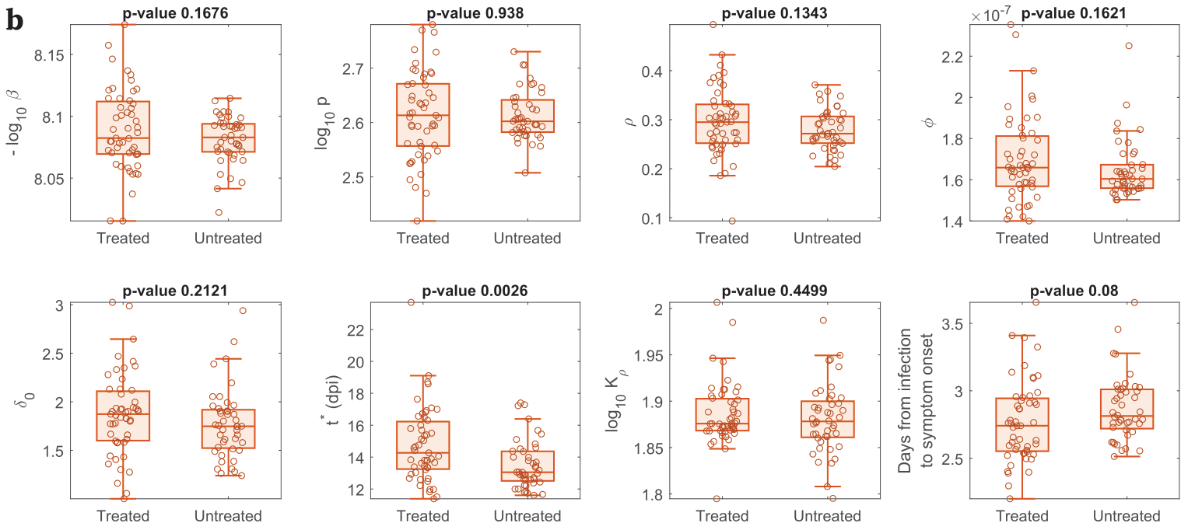

**S6 Fig.** Model fits recapitulate viral dynamics and quantify differences in the characteristics between treated and untreated individuals. **a.** Model fits to nasal viral loads of treated/rebound (pink), treated/non-rebound (blue), untreated/rebound (red), and untreated/non-rebound (green) individuals. The shaded area is the duration of N-R treatment. The dotted horizontal line is the limit of detection (LoD) for the RT-qPCR assay. Filled and open circles are data above and below the LoD, respectively. The dotted black vertical line indicates the estimated time from infection to symptom onset. **b.** Box plots of best fit parameters and timing of N-R stratified by individuals who were treated vs. those who were not. The lower and upper limits of the box represent the first and third quartile, respectively. The line inside the box is the median and the whiskers connect the top/bottom of the box to the max/min values that are not outliers (data points further than 1.5 times the interquartile range). Overlaid circles are individual parameter values. Time of N-R initiation relative to symptom onset was recorded for each individual (except non-rebounder 23, whose symptom onset is imputed at one day prior to their first positive test). Since we have a sufficient number of participants in the treated and untreated groups, we used a two-sample t-test without assuming equal variances to calculate the P-values.

**S7 Text: Statistics of rebound in untreated individuals**

We collected data on the percentage of untreated individuals that rebound from the literature. The definitions of rebound are not the same across these studies. When there are multiple definitions provided in the same study, we chose the one that best matches with the cohort of 51 individuals used in this study. A summary is provided in S4 Table.

|  |  |  |
| --- | --- | --- |
| Rebound percentage | Number of rebound out of total sample size | Reference |
| 6.8% | 3 of 44 | Extended Edelstein [12] |
| 1.8% | 1 of 55 | Edelstein et al. [12] |
| 13% | 34 of 261 | Deo et al. [13] |
| 4.5% | 170 of 3787 | Wong et al. [14] |
| 1.7% | 17 of 980 | EPIC-HR trial [15] |
| 0.6% | 68 of 11688 | Wong et al. [16] |
| 9.3% | 4 of 43 | Pandit et al. [17] |
| 4% | 1 of 25 | Dai et al. [18] |
| 3% | 40 of 1334 | Hay et al. [19] |

**S4 Table.** Statistics of rebound in untreated individuals.“Extended Edelstein” refers to the data from the ongoing extension of Edelstein et al. [12] under the selection criteria in the Data Section of the main text. “Edelstein et al. [12]” refers to the rebound percentage reported by Edelstein and colleagues in their original study [12]. For the data from Deo et al. [13], we use their definition of high viral rebound, i.e. a viral load of 105 copies/ml which implied presence of infectious virus. For the data from Hay et al. [19], we use their definition corresponding to a transient rebound (at least 2 viral measurements above 30 Ct, i.e., negative, then at least 2 viral measurements below 30 Ct).

**S8 Text: *In silico* construction and analysis**

Using the selection criteria outlined in the Methods (main text), we obtained 47,115 admissible parameter sets (out of 50,000 random sets). We used these admissible parameter sets to simulate treatments of varying durations starting at different times and to calculate the probability of rebound. Specifically, each *in silico* cohort consists of 100 randomly chosen patients from the 47,115 above, to whom we applied the treatment, and calculated the fraction of those that rebound. We repeated this process 20 times and plotted the results over the 20 cohorts as boxplots in Fig 3. Examples of 100 viral trajectories for the 5- and 6-day N-R under different treatment assumptions are shown in S7a Fig. The distributions of sampled parameters and 100 sampled untreated trajectories are plotted in S7b, c Fig. The comparison of rebound in untreated individuals is presented in S7d Fig, and shows slightly higher rebound statistics but still within the range as those reported in the 8 clinical studies (S7 Text). This is expected because in our *in silico* analysis rebound is classified as VL increasing above 4 log10 viral RNA copies/mL at any time after stopping N-R. If we sample the *in silico* individuals at frequencies similar to that used in clinical practice, then the simulated rebound statistics are similar to that of the 8 clinical studies. For example, assuming viral measurements are taken once every 2 days and defining viral rebound to be 2 consecutive viral measurements above 4 log10 viral RNA copies/mL after being below this threshold, the simulated rebound statistics has a median rebound of 7.5 percent with min and max rebounds of 3 and 10 percent, respectively. If we assume viral measurements are taken once every three days, rebound frequency further drops to a median of 6 percent with min and max rebounds of 1 and 8 percent respectively. From our *in silico* simulations, we also found that the viral rebound for patients treated within 2 days of symptoms onset (Fig 3) is, on average, higher than the rebound in untreated individuals. However, significant variation exists among those treated within 2 days of symptom onset, with a mean rebound rate of 12.2% (95% CI: 3%-22%). Finally, since the choice of definition of rebound tends to affect the percentage of rebound similarly across all scenarios, we elected to use the simple definition of VL going above 4 log10 viral RNA copies/mL after N-R. As demonstrated in S7a Fig, this definition captures well the rebound individuals.

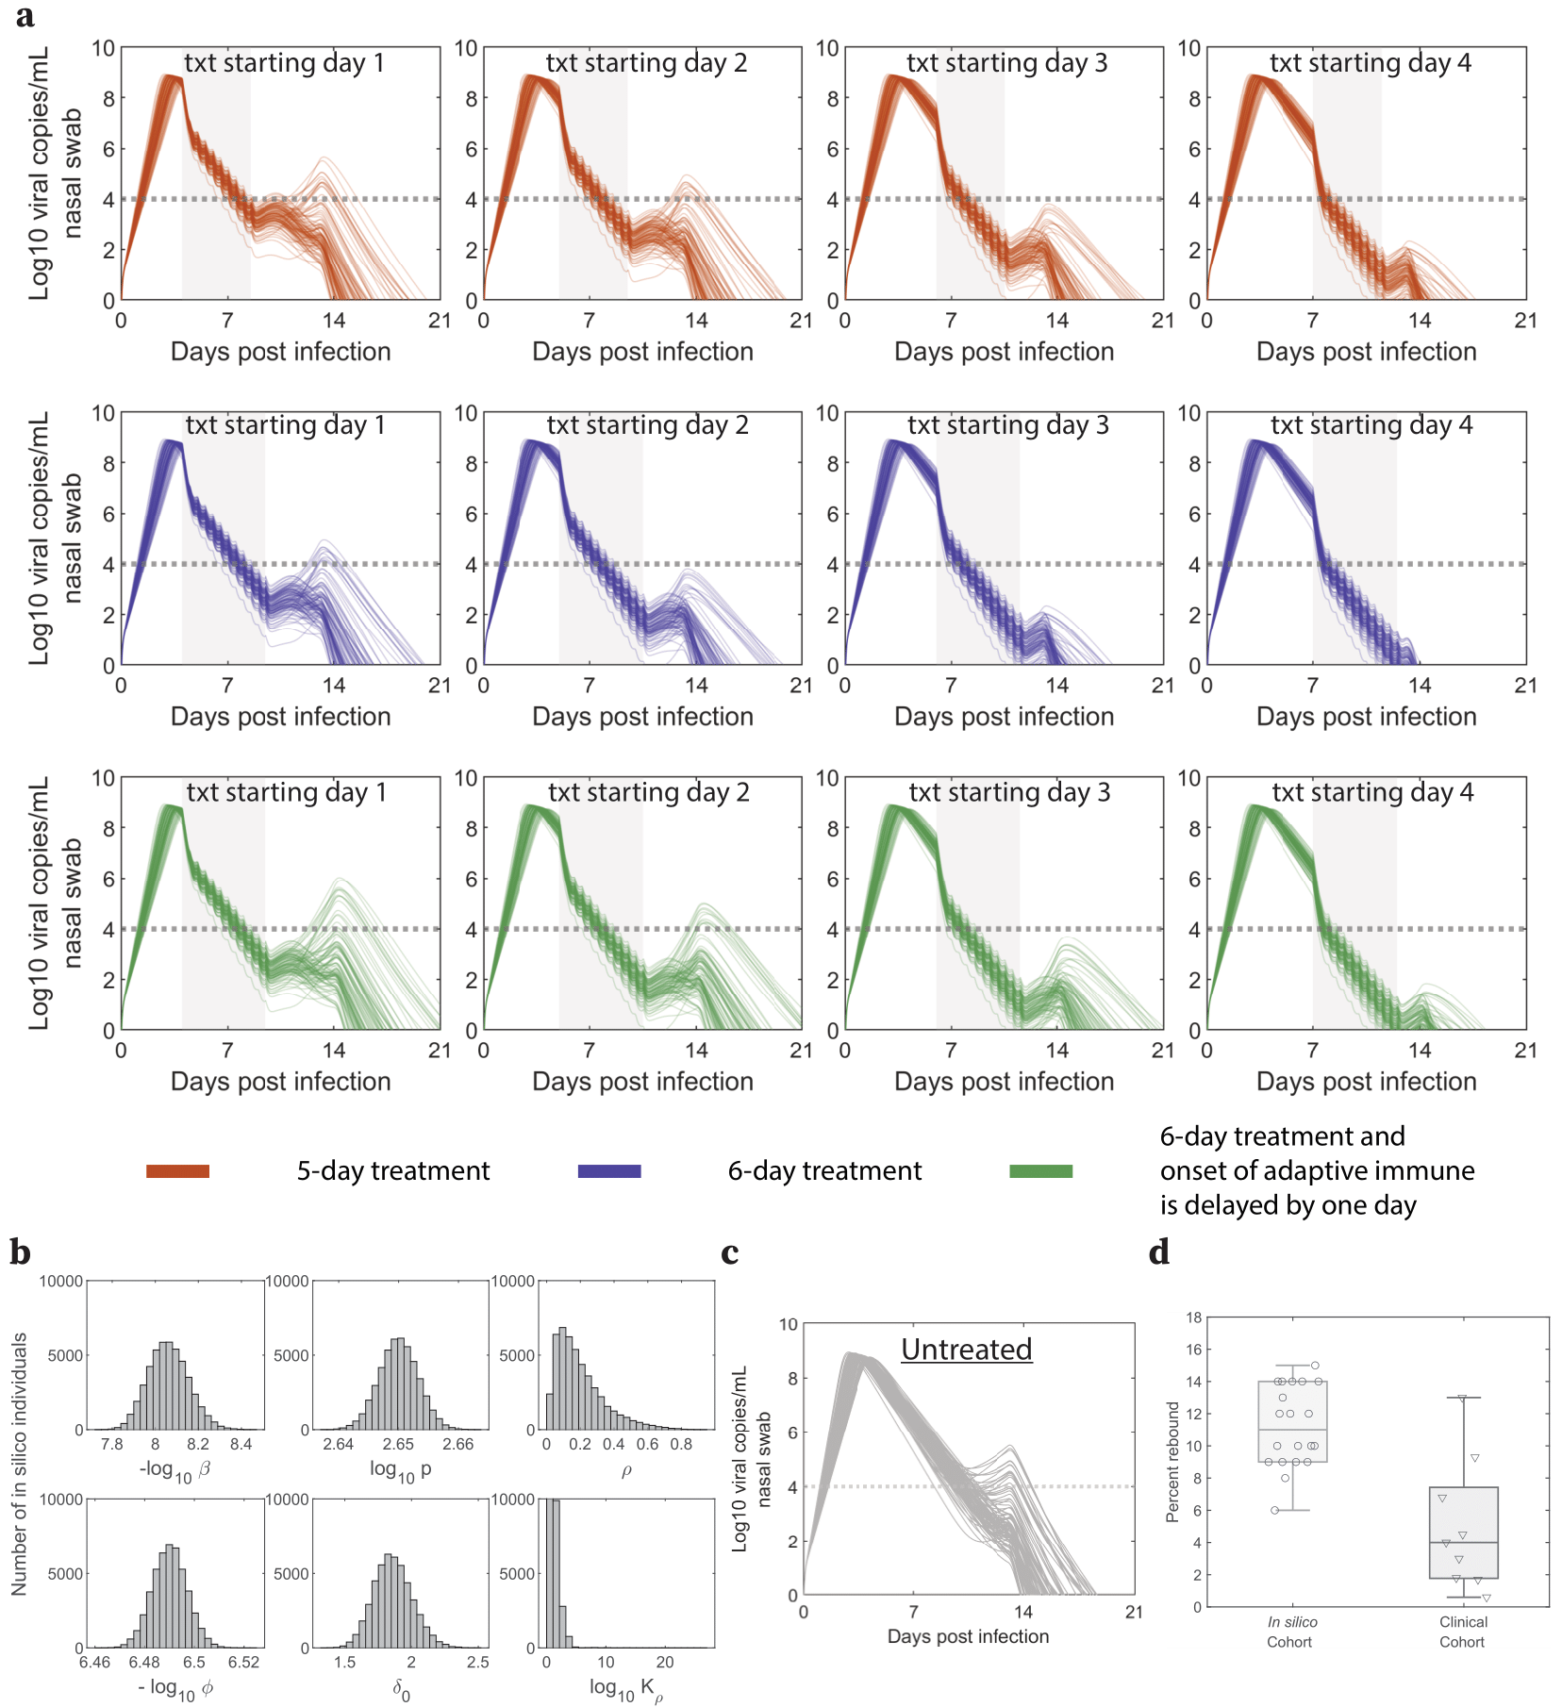

**S7 Fig.** Sample trajectories and parameter distribution for the *in silico* cohort of individuals. **a.** 100 samples of viral dynamics under the three different treatment scenarios. The shaded area is the duration of N-R treatment (txt), which starts 1, 2, 3 or 4 days after symptom onset. The grey dotted horizontal lines are the threshold for rebound classification (4 log10 copies/mL). **b.** Histograms of parameter distribution for the full cohort of *in silico* individuals. **c.** 100 samples of viral dynamics trajectories without treatment. **d.** Light gray box shows the percentage of expected rebound without treatment, which is compared to the data of rebound from 8 clinical cohorts (dark gray box/triangles).

**S9 Text: The sensitivity of viral rebound to treatment initiation time and the duration of treatment assuming N-R delays the development of an adaptive immune response**

We also examine the sensitivity of viral rebound to the timing and duration of N-R, similar to the results in Fig 3 (main text), but under the assumption that the onset of the adaptive immune response is delayed more with longer treatments. Specifically, we set the delay to be 0.5 day for 6-day treatments, 1 days for 7-day treatments, 1.5 days for 8-day treatments, and 2.5 days for 10-day treatments relative to a 5-day treatment. Note that these delays were chosen based on the average delays of 1.23 days, with 95% CI of [0.44, 2.03] days, for the onset of adaptive immune between treated and untreated individuals (S6 text). Specifically, at the upper range of 2.03 days of delay, on average, each additional day of treatment (if initiated early) would delay the onset of adaptive immune response by about 0.4 days. Furthermore, a smaller delay effect would not affect the trend observed in our simulations, meaning these results also encompass scenarios where the delay in the maturation of the adaptive immune response associated with extending N-R is shorter. The simulations (S8 Fig) show a similar trend to the results without a delay in the onset of adaptive immune response (Fig 3).

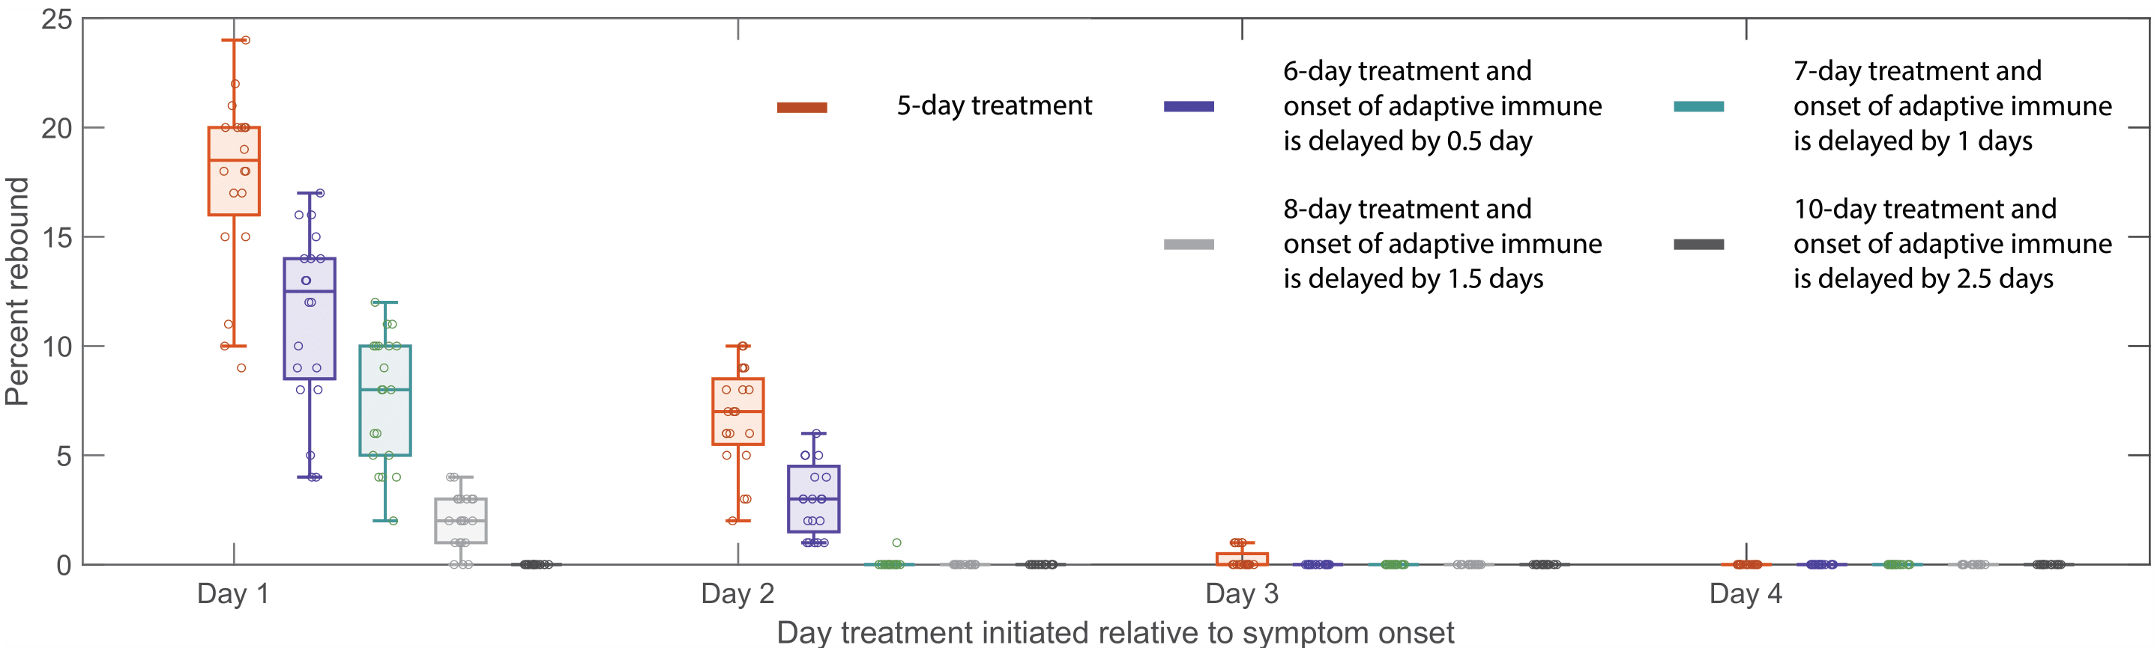

**S8 Fig.** **Predicted rebound relative to the time and duration of treatment**. Predicted rebound relative to 5-, 6-, 7-, 8-, and 10-day of N-R. Symptom onset is assumed to occur three days post infection. Boxplots of the percentage of rebound cases from 20 *in silico* cohorts, each with 100 individuals, for different treatment initiation times. Each open circle represents the rebound percentage from one cohort. The extended duration of N-R (beyond a 5-day treatment course) is assumed to cause a delay in the onset of adaptive immune response proportional to the extension.

**S10 Text: The trade-off between the increasing drug cost with longer treatments and the reduction in rebound**

There is a trade-off in the reduction of rebound and the increase in cost associated with longer duration. An optimal duration could therefore minimize both the cost and the rebound probability, which consequentially improve the availability of the drug for more people. To examine this question, we plot the “value” of extending N-R, defined as the median reduction in rebound for each treatment duration divided by a normalized cost, i.e., a 5-day treatment costs 1 unit, a 6-day treatment costs 1.2 units, and so on. S9 Fig shows the results for treatment initiated within 2 days of symptom onset. In these scenarios, extending N-R to 6-day results in the largest increase in “value”, i.e., sharpest increasing slope. The “value” peaks between 7- and 8-day under different scenarios, implying that the optimal duration to minimize rebound and cost is between 7- and 8-day. Note that in these simulations, symptom onset is assumed to be 3 days post infection and similar trends are observed if symptoms are assumed to be 2- or 4-day post infection. However, a 10-day course of N-R may be necessary if treatment is initiated very early and preserves a very large number of target cells, which would almost guarantee to allow rapid viral rebound after a standard course of treatment.

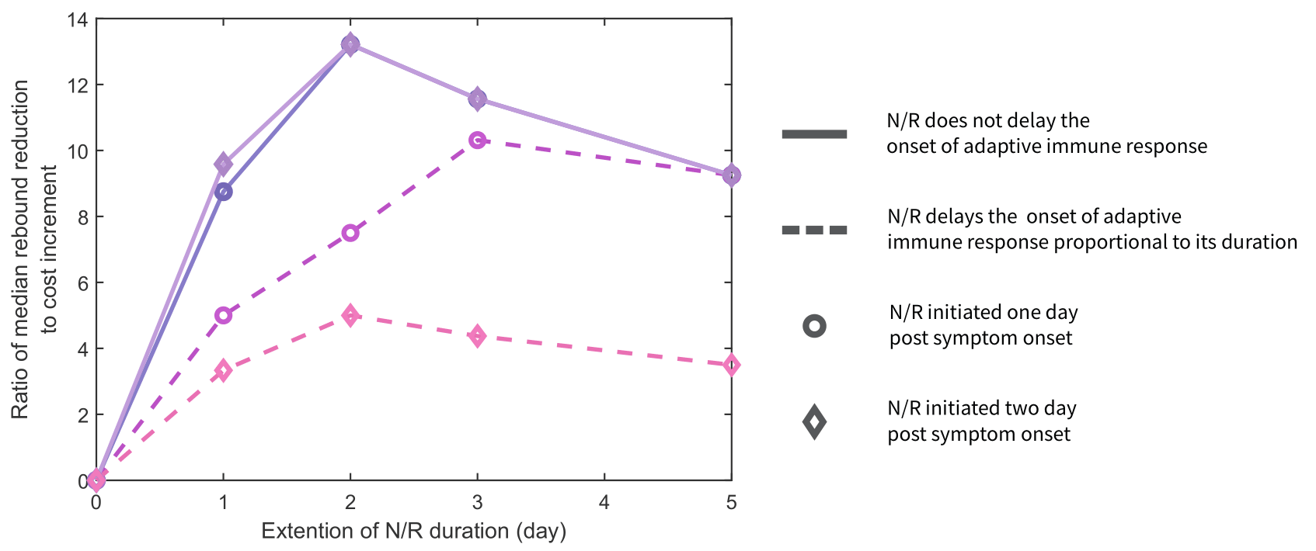

**S9 Fig.** Optimal N-R duration to minimize cost and rebound probability. The median rebound reduction is based on treatment initiated within 2 days of symptom onset in Fig 3 (main text) and S8 Fig. Peak ratios indicate optimal treatment based on cost and rebound reduction.

**References**

[1] Dixit NM, Perelson AS. Complex patterns of viral load decay under antiretroviral therapy: influence of pharmacokinetics and intracellular delay. J Theor Biol 2004;226:95–109. https://doi.org/10.1016/j.jtbi.2003.09.002.

[2] Fact Sheet for Healthcare Providers: Emergency Use Authorization for Paxlovid 2024. https://www.fda.gov/media/155050/download

[3] Perelson AS, Ribeiro RM, Phan T. An explanation for SARS-CoV-2 rebound after Paxlovid treatment. Infectious Diseases (except HIV/AIDS); 2023. https://doi.org/10.1101/2023.05.30.23290747.

[4] Carlin AF, Clark AE, Chaillon A, Garretson AF, Bray W, Porrachia M, et al. Virologic and Immunologic Characterization of Coronavirus Disease 2019 Recrudescence After Nirmatrelvir/Ritonavir Treatment. Clin Infect Dis 2023;76:e530–2. https://doi.org/10.1093/cid/ciac496.

[5] Esmaeili S, Owens K, Wagoner J, Polyak SJ, White JM, Schiffer JT. A unifying model to explain frequent SARS-CoV-2 rebound after nirmatrelvir treatment and limited prophylactic efficacy. Nat Commun 2024;15:5478. https://doi.org/10.1038/s41467-024-49458-9.

[6] Samuel CE. Antiviral Actions of Interferons. Clin Microbiol Rev 2001;14:778–809. https://doi.org/10.1128/CMR.14.4.778-809.2001.

[7] Talemi SR, Höfer T. Antiviral interferon response at single‐cell resolution. Immunol Rev 2018;285:72–80. https://doi.org/10.1111/imr.12699.

[8] Voigt EA, Swick A, Yin J. Rapid induction and persistence of paracrine-induced cellular antiviral states arrest viral infection spread in A549 cells. Virology 2016;496:59–66. https://doi.org/10.1016/j.virol.2016.05.019.

[9] García-Sastre A, Biron CA. Type 1 Interferons and the Virus-Host Relationship: A Lesson in Détente. Science 2006;312:879–82. https://doi.org/10.1126/science.1125676.

[10] Pawelek KA, Huynh GT, Quinlivan M, Cullinane A, Rong L, Perelson AS. Modeling Within-Host Dynamics of Influenza Virus Infection Including Immune Responses. PLoS Comput Biol 2012;8:e1002588. https://doi.org/10.1371/journal.pcbi.1002588.

[11] Saenz RA, Quinlivan M, Elton D, MacRae S, Blunden AS, Mumford JA, et al. Dynamics of Influenza Virus Infection and Pathology. J Virol 2010;84:3974–83. https://doi.org/10.1128/JVI.02078-09.

[12] Edelstein GE, Boucau J, Uddin R, Marino C, Liew MY, Barry M, et al. SARS-CoV-2 Virologic Rebound With Nirmatrelvir–Ritonavir Therapy: An Observational Study. Ann Intern Med 2023;176:1577–85. https://doi.org/10.7326/M23-1756.

[13] Deo R, Choudhary MC, Moser C, Ritz J, Daar ES, Wohl DA, et al. Symptom and Viral Rebound in Untreated SARS-CoV-2 Infection. Ann Intern Med 2023;176:348–54. https://doi.org/10.7326/M22-2381.

[14] Wong CKH, Lau KTK, Au ICH, Lau EHY, Poon LLM, Hung IFN, et al. Viral burden rebound in hospitalised patients with COVID-19 receiving oral antivirals in Hong Kong: a population-wide retrospective cohort study. Lancet Infect Dis 2023;23:683–95. https://doi.org/10.1016/S1473-3099(22)00873-8.

[15] Anderson AS, Caubel P, Rusnak JM. Nirmatrelvir–Ritonavir and Viral Load Rebound in Covid-19. N Engl J Med 2022;387:1047–9. https://doi.org/10.1056/NEJMc2205944.

[16] Wong GL-H, Yip TC-F, Lai MS-M, Wong VW-S, Hui DS-C, Lui GC-Y. Incidence of Viral Rebound After Treatment With Nirmatrelvir-Ritonavir and Molnupiravir. JAMA Netw Open 2022;5:e2245086. https://doi.org/10.1001/jamanetworkopen.2022.45086.

[17] Pandit JA, Radin JM, Chiang DC, Spencer EG, Pawelek JB, Diwan M, et al. The Coronavirus Disease 2019 Rebound Study: A Prospective Cohort Study to Evaluate Viral and Symptom Rebound Differences in Participants Treated With Nirmatrelvir Plus Ritonavir Versus Untreated Controls. Clin Infect Dis 2023;77:25–31. https://doi.org/10.1093/cid/ciad102.

[18] Dai EY, Lee KA, Nathanson AB, Leonelli AT, Petros BA, Brock-Fisher T, et al. Viral Kinetics of Severe Acute Respiratory Syndrome Coronavirus 2 (SARS-CoV-2) Omicron Infection in mRNA-Vaccinated Individuals Treated and Not Treated with Nirmatrelvir-Ritonavir. Infectious Diseases (except HIV/AIDS); 2022. https://doi.org/10.1101/2022.08.04.22278378.

[19] Hay JA, Kissler SM, Fauver JR, Mack C, Tai CG, Samant RM, et al. Quantifying the impact of immune history and variant on SARS-CoV-2 viral kinetics and infection rebound: A retrospective cohort study. eLife 2022;11:e81849. https://doi.org/10.7554/eLife.81849.